

Hi, I’m Helga
KickStarter 2026
GET BOARDROOM-READY


I’m your KickStarter ‘Connector in Chief’

Just a little bit about me before we get started…

Who I am:
- I grew up in a community-minded environment that encouraged me and my sisters to consider the world around us. Read my story.
- I’m a keen bushwalker, a volunteer and a former dance instructor. I love my work yet I aim to put aside time to be outside and with family and friends.
What I’m proud of:
- I’m the host of the Take on Board podcast, where we talk about all things boards and governance.
- Take on Board has evolved beyond a podcast into a supportive community of women and gender diverse people.
What I do:
- I’ve held leadership roles in government, not-for-profit and membership organisations. Read more on LinkedIn.
- Working with individuals or organisations, I provide governance, facilitation and coaching services.
- I specialise in strategy and planning, governance and stakeholder engagement. Find out what it’s like to work with me (testimonials).
- I’m on a number of boards and committees, including chairing the Workplace Injury Commission. Let me know if you would like to see my full board CV.
Why I created KickStarter

When I established KickStarter in 2013 there was very little around to help women and gender diverse potential directors find the practical tools to apply for their first board role.

I wanted to help people gain clarity about their strengths and provide the kind of supportive and encouraging environment that would set them up for success in governance.
Contents | Hi, I’m Helga  * A little bit about me before we get started  Before we start…  * What to expect  * Ground rules  You and your board strengths  Module 1: Skills  * The skills you need to focus on for a board role  Module 2: Alignment  * Identifying the right organisation/board for you  Module 3: Commitment  * The four functions of directorship  Module 4: Diversity, equity, inclusion  * Inherent vs acquired diversity  Get ready to apply for a board  Module 5: Pitch  * Your pitch to say why you’ll make a fabulous director  Module 6: Board resumé  * Build your board/governance resumé  Module 7: Where to look  * Where to find a board role  Interview and board role prep  Module 8: Interview  * What to think about before, during and after the interview  Module 9: Eyes wide open  * Program review and going in to your first board role with your eyes wide open…  Module 10: Progress sessions  * The one and three-month online progress sessions  Handouts  * The module-by-module list of resources

Before we start

What to expect…

The modules in this fast-moving program require very active participation. It’s not the kind of program where you get to sit back and listen.

You’ll be expected to:
- Actively engage with the group
- Bring your enthusiasm and open mind
- Ask questions and discuss ideas
- Share your wisdom and experience
After using this playbook, you’ll know how to:
- Identify and promote your board skills and strengths
- Search, find and apply for your first board role
- Prepare for the interview and board role
And you’ll have:
- A succinct pitch to promote board strengths
- A targeted board resumé
- Your own Take on Board cheer squad!

Stay in touch

By now you should have received your KickStarter online introductory booklet. It’s where you’ll find your KickStarter cohort’s bios and contact details.

You can also keep in touch with your group through:
- The Take on Board Facebook group
- Your Take on Board Signal group
You’ll need to download the Signal mobile or desktop app through the App Store or Google Play Store to keep in touch with your Take on Board group.

Let me know when you have downloaded the app and I'll invite you to the group. If you’re already on Signal, you may need to update to a newer version. I won’t be able to invite you to the group unless you have the most up-to-date version.

Ground rules

Before we get stuck into the first module, let’s set the group ground rules together.

Discuss what you think we need to do and how we need to be to make sure these sessions are as constructive as possible?

Don’t forget to take notes. We’ll write up the ground rules together.

WHAT DO WE NEED TO DO? | HOW DO WE NEED TO BE?

agreed Group GROUND RULES

Module 1: Skills

Governance vs operational

Handout (link): The Distinguishing Governance from Management (2008) edition of the Great Boards journal says:

‘What is the difference between governance and management?’ is by far the question that not-for-profit executives and directors ask most often. Effective boards understand the difference between governing and managing; dysfunctional boards do not.

Look at the difference between governance and operational, and the different issues each face.

WHAT DOES THE BOARD DO? | WHAT DOES MANAGEMENT DO?

Skills for each stage of the organisation’s development

The skills you need to govern an organisation might vary depending on what stage of development an organisation is at. For example, the governance skills required for a start-up might be different to the skills required for a mature organisation.

The Canadian Angel Investment Foundation describes these stages as:

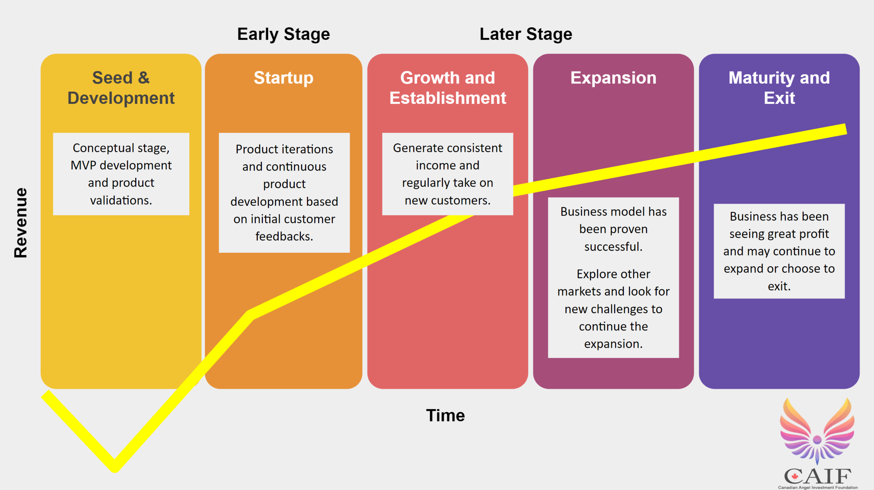

Let’s think about these board skills…

Considering these slightly different development stage categories, write down what governance skills are required and where they align to the stages of development of an organisation.

Stage | governance skills required
Seed and development or startup

Growth and expansion

Maturity

Exit

Hard vs soft skills

One tool a board uses (or should use) to make sure it has ‘the right mix of competencies to meet the company’s evolving needs’ (AICD’s Board Recruitment factsheet) is a ‘board skills matrix’.

A board skills matrix often has a mix of hard (or technical) and soft (or EQ) skills. Your hard skills (e.g. stakeholder engagement, law, finance, people and culture) might get you the interview for the board, but your soft (EQ) skills (e.g. critical thinking, collaboration) are likely to secure you the role and lead to success in the boardroom.

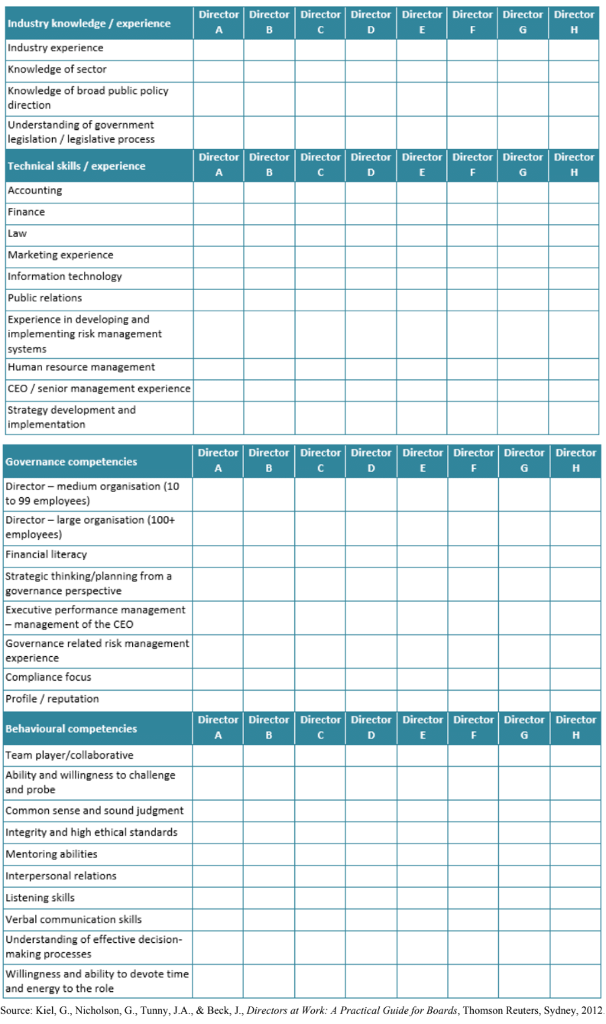
Your hard and soft governance skills

Discuss examples of hard and soft governance skills. Answers to be discussed as a group.

HARD SKILls examples | soft skills examples

YOUR HARD SKILls | yOUR soft skills
Skills quadrant
This self-knowledge exercise can help you to identify the skills and competencies you have and those you would like to develop in the pursuit of a new role with a board or organisation.

Homework 1: Fill out the VIA Signature Strengths Questionnaire to work out your top strengths (it takes 20 minutes).
Homework 2: We’ll touch on the skills quadrant today, although you’ll need to put in an extra hour or two to finish it off properly.

Step 1: Skills and competencies you have

Consider the skills and/or competencies you currently have. Of these skills, determine which skills are the ones you would like to use in your new role – those you won’t need to actively market. Write them down in quadrant no.1.

Write down the skills you have but don’t want to use in quadrant no.3. For example, you have excellent financial audit skills but don’t want a treasurer role on a board.

Step 2: Consider the skills you would like to develop or enhance

Of these skills, determine which skills you would like to use/develop in your future role or plans. Write them down in quadrant no.2. There might be a number of skills you’d like to develop but don’t want to use in the future role. Write these down in quadrant no.4.

Step 3: What have you left off?

What would your mentor add in if you were to ask them? What would your friend or partner suggest you add? What would an admired work colleague advise you to include?

Step 4: Interpreting your skills quadrant
- Skills I have / skills I want to use: Use these to promote to organisations or boards.
- Skills I want to develop / skills I want to use: This quadrant represents your opportunities. Can you offer other skills and learn/enhance this new skill at the same time? What would you need to declare to yourself/the organisation/board to follow this path with integrity?
- Skills I have / skills I don’t want to use: Is this open for negotiation? How does this equate with skills demand from the sector? Would you be willing to use these skills if a particular role included all other factors you are seeking?
- Skills I want to develop / skills I don’t want to use: These skills aren’t related to current plans and goals.
Step 5: You may now want to consider how this aligns with your signature strengths.

Step 6: Use this enhanced self-knowledge in compiling a ‘statement of interests and competencies’ which you could use to guide your search and in application processes.

Skills I want to use | 1. Skills I have / skills I want to use | 2. Skills I want to develop / skills I want to use
 | 3. Skills I have / skills I don’t want to use | 4. Skills I want to develop / skills I don’t want to use
Skills I do not want to use
 | Skills I have Skills I want to develop

Module 2: Alignment

Your governance purpose statement

At the end of this module, you will have a short governance purpose statement. It will be written yet designed to be spoken. It will help you identify aligned organisations and boards in your search for a director role. To help you write your purpose statement, we’ll look at:
- Step 1: Past successes
- Step 2: Core values
- Step 3: Contributions
- Step 4: Goals
- Step 5: Write your governance purpose statement
First… what are you proud of?
prompt: | YOUR ANSWER
Something I’m proud of from the last 10 years

Something I’m proud of from the last two years

Something I’m proud of from the last month

The governance purpose statement process

Step 1: Your past successes

Individually, write down four or five examples of personal success in recent years – at work, in your community, at home. Check your ‘I’m proud of’ list for ideas.

Discuss your successes to see if there are any themes.

prompt: | YOUR ANSWER
Success 1

Success 2

Success 3

Success 4

Success 5

success themes

Step 2: Your core values

Circle the ones that apply to you. Use this list or come up with your own. Once you’ve circled all the ones that apply, try to narrow down your top 10.

Accomplishment | Ethics | Participation
Accountability | Excellence | Partnership
Accuracy | Fairness | Patience
Achievement | Family | Peace
Acknowledgment | Financial security | Performance
Adaptability | Focus | Perseverance
Adventure | Forgiveness | Personal development
Aesthetics | Forward the action | Personal fulfilment
Authenticity | Free spirit | Personal power
Balance | Freedom to choose | Personal relationships
Beauty | Friendship | Physical exercise
Being liked | Full self-expression | Positive energy
Being the best | Future generations | Power
Belonging | Generosity | Pride
Career focus | Growth | Productivity
Caution | Harmony | Professional growth
Coaching | Health | Quality
Collaboration | Honesty | Quality of life
Commitment | Human rights | Recognition
Community | Humility | Reliability
Compassion | Humour/fun | Respect
Comradeship | Image | Responsibility
Conflict resolution | Inclusive | Risk taking
Conformity | Independence | Romance
Connectedness | Innovation | Security
Contribution | Inspirational | Self-discipline
Control | Integrity | Service
Cooperation | Interdependence | Societal common good
Counselling | Intuition | Spirituality
Courage | Joy | Status
Courtesy | Knowledge | Success
Creativity | Lack of pretense | Sustainable
Determination | Learning | Teamwork
Dialogue | Lightness | To be known
Different | Logic | Tradition
Directness | Making a difference | Trust
Diversity | Material assets | Vision
Ease with uncertainty | Meaning | Vitality
Education | Mission focus | Wealth
Efficiency | Nurturing | Wisdom
Elegance | Nutrition | Zest
Empowerment | Open Communication
Enthusiasm | Openness
Environmental awareness | Orderliness
Your top three values

Now, let’s narrow your list down from 10 to three values.

You may find it useful to combine values as long as the distinctions are not lost. For example, ‘honesty/integrity/truthfulness’ has a single theme, however ‘honesty/integrity/freedom’ mixes concepts.

your top 10 VALUES

your top three VALUES
Value 1

Value 2

Value 3

Step 3: Your contributions

Individually, write down how – in an ideal situation – you would best contribute to the world, family, current/future employer, friends and community.

Discuss these contributions to see if there are any themes.

prompt: | YOUR ANSWER
Community

Family

Friends

Employer or future employer (or board/future board)

The world in general

contribution themes

Step 4: Your goals

Write down your short, medium and long-term goals.

Discuss these goals to see if there are any themes.

prompt: | YOUR ANSWER
Short-term

Medium-term

Long-term

goal themes

Step 5: Write your governance purpose statement

Now let’s put all this together!

Looking at your achievements, values, contributions and goals, write a 50-100-word governance purpose statement. It might take a few goes – a bit of crossing out and rewriting.

If you need it, here’s an example:

‘Building on my achievements in the bringing of people and ideas together in the environmental and human rights sector, and my values of equity and inclusion, my contribution to the boardroom will be in an organisation that has a long-term vision that makes me feel hopeful and where I can contribute my strategic thinking.’

PURPOSE statement

Let’s pause to reflect…
What does your governance purpose statement tell you about the type of board you’d like to join?
THE TYPE OF BOARD I’D LIKE TO JOIN

Module 3: Commitment

General duties of directors

Handout (link): The AICD’s general duties of directors factsheet outlines the ‘core legal duties that apply to directors under the Corporations Act 2001 (Cth) (Corporations Act) and common law’:

‘The relationship between a director and a company is fiduciary in nature, meaning that a director undertakes to act in the interests of the company and not in his or her own interests.

The overriding duty of a fiduciary is the obligation of undivided loyalty. This obliges the director to act honestly, in good faith and to the best of his or her ability in the company’s interests. A director must not allow conflicting interests or personal advantages to override the company’s interests.’
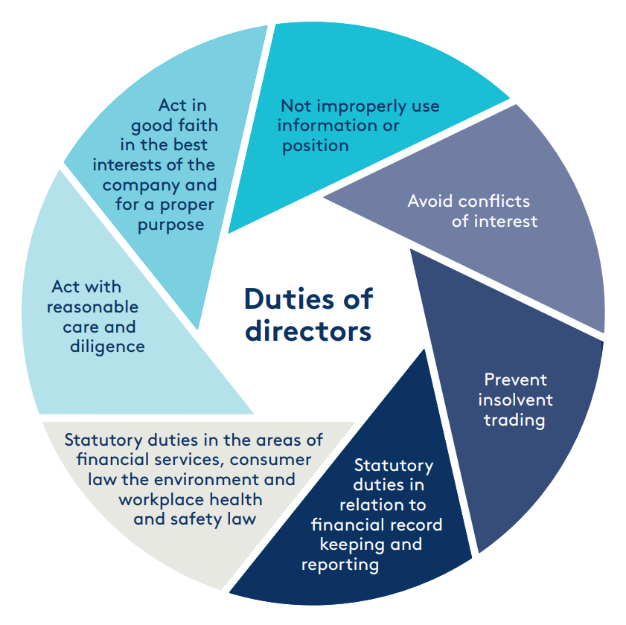

What each of these duties requires

Looking at these general duties of directors, expand on what each duty requires, as well as any consequences if breached.

Answers will be discussed as a group.

DUTY | REQUIREMENTS
Act in good faith in the best
interests of the company and
for a proper purpose

Not improperly use information or
position

Avoid conflicts of interest

Prevent insolvent trading

Statutory duties in relation to
financial record keeping and
reporting

Statutory duties in the areas of
financial services, consumer law the environment and workplace health and safety law

Act with reasonable care and
diligence

The roles and behaviours required of directors

Handout (link): First published in Company Director Magazine in 2009, Thoughtpost Governance’s updated 4-in-1 Directorship Model identifies four broad functions of directorship:
- Performing: board performance through role clarity and board composition, culture and processes
- Decision-making: direction setting for delegations, strategy, risk appetite and framework, culture, CEO, stakeholder engagement and major decisions
- Advising: assist management with knowledge, experience, networks and mentoring
- Monitoring: overseeing performance, capacity, compliance and accountability
Considering these four functions of directorship, look at what roles and behaviours are required of directors. Answers will then be discussed as a group.

FUNCTION | roles | BEHAVIOURS
Performing

Decision making

Advising

Monitoring

Due diligence

It’s important that you do your due diligence before you join a board.

prompt: | YOUR ANSWER
What questions you would ask?

Where can you find information about the organisation?

Let’s pause to reflect…

What stood out for you in this module?

WHAT I LEARNT ABOUT GENERAL DUTIES OF DIRECTORS

Module 4: Diversity, equity and inclusion

Diverse, equitable and inclusive boards are now known to be stronger (yet sometimes, harder!).

In this session we’ll explore diversity, equity and inclusion. In doing so, you’ll be reflecting on your own identity. Please feel free to share as much or as little about yourself as you wish.

Handout (link): The AICD’s Which Two Heads are Better than One? book says:

‘Generating diversity of thinking requires more diligence than simply assembling
a disparate group of people, encouraging random brainstorming and crossing one’s
fingers.’

In small groups of 2-4, look at what you have in common and what is unique to you. Answers will then be discussed as a group.

prompt: | YOUR ANSWER
What are three things that each member of your group has in common?

What is one thing that is unique to you (e.g. unique to you as an individual, not unique to your group as a whole)?

Inherent vs acquired diversity
- Inherent diversity = characteristics you’ve inherited (i.e. race, ethnicity, birthplace, age)
- Acquired diversity = characteristics you’ve acquired through experiences (i.e. education, places you’ve lived, socioeconomic status)
Handout (link): Better Decisions Through Diversity (Kellogg School of Management)
Handout (link): The How Diversity Can Drive Innovation article (Harvard Business Review) about a research study that provided ‘compelling evidence that diversity unlocks innovation and drives market growth’ says:

‘Inherent diversity, however, is only half of the equation. Leaders also need acquired diversity to establish a culture in which all employees feel free to contribute ideas.’

Your diversity: inherent | Your diversity: acquired

Advantages and disadvantages of diversity

A number of studies have shown that diversity can enhance decision-making. Yet it can also make it more challenging.

advantages | disadvantages

The benefits of constructive tension

Think about a time when you were involved in a group with people who were different to you – and thought different to you – and you needed to make a difficult decision together.

prompt: | YOUR ANSWER
What happened?

How was it managed?

How can you learn from it?

Let’s consider constructive tension in the boardroom

Constructive tension is a positive attribute of a diverse board.

What does this reflection – and your wider experience – tell you about personal differences and difficult conversations in the boardroom?

prompt: | YOUR ANSWER
What can boards do to encourage diversity, equity and inclusion in the boardroom?

What can board chairs do to encourage diversity, equity and inclusion in the boardroom?

Let’s pause to reflect…

What stood out for you in this module?

WHAT I LEARNT ABOUT diversity, equity and inclusion

Module 5: Pitch

A powerful, succinct pitch for why YOU will be a fabulous director will give you the extra confidence boost when you apply for the board role and land the interview.

Use a 'governance lens' as much as possible in your responses.

PROMPT | YOUR ANSWER
I’m a…

And my strengths are____, ____ and ____.

My current (or most recent role) is...

Some of my achievements include...

My background is…

I’m also…

I’m looking forward to using my skills of ____, ____ and ____ to make a contribution to ____.

Refine your pitch

Now, let’s put it all together! Then, practice makes perfect…

This won’t be the last time you refine your pitch. You might refine your pitch every time you apply for a board role.

Homework 1: Refine your pitch
Homework 2: Call me and practice your pitch (leave a message if I don’t answer)

PUT IT ALL TOGETHEr

Module 6: Board resumé

Handout (link): Take on Board podcast episode 6 – developing a governance CV

You’ll need to use a board resumé – not your executive resumé – to apply for a board role.

This module will help you start your board resumé, although you’ll likely need to finish and refine it in your own time. It will take a few re-drafts to get right. I re-draft mine often.
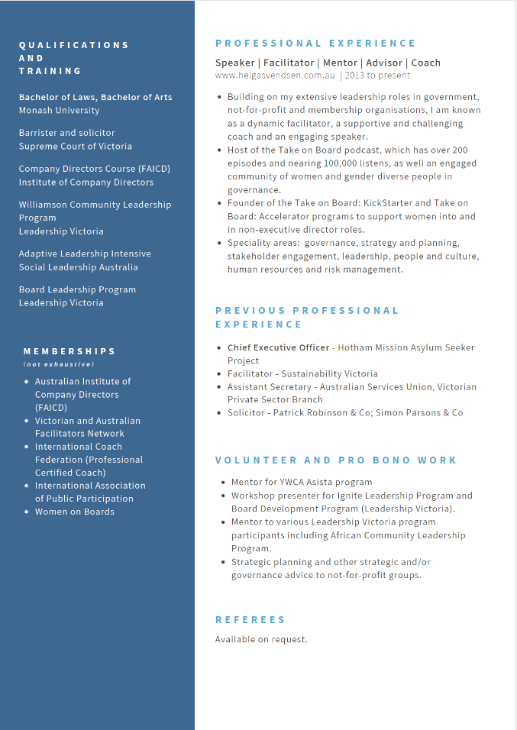
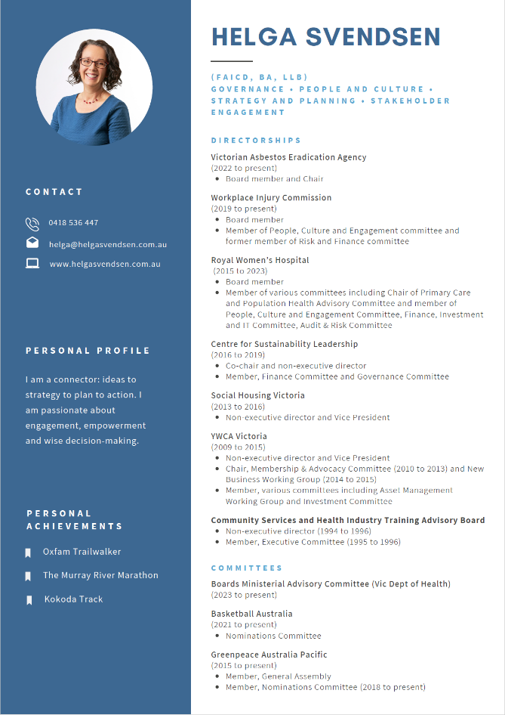

Before we start…

You will have a range of experience that has made you who you are today – remember that only some of it will be relevant to a board.

Tips:
- Draw on your purpose statement and the work we did with your pitch
- Keep to two pages – three if you have to
- You may think ‘I have nothing’, together I’m sure we’ll find things that are relevant!

Challenge, action, result

Source: The ‘what does a CAR have to do with your resumé’ article by Laura Smith-Proulx in Career Rocketeer (no longer available) said:

‘The most powerful, attention-getting resumés tell entire stories, helping employers understand how you’ll be the best candidate to tackle their business problems.

‘To create a resumé that truly represents the full spectrum of what you offer, consider taking a look at the results of your work using the C-A-R (Challenge-Action-Result) method.’

The C-A-R method consists of these steps:
- First, describe the situation you faced at work (Challenge)
- Then what you did when faced with it (Action)
- Last but not least, the outcome (Result) that you achieved is the critical part
The article had this example of how to use the C-A-R strategy:
- Original sentence: Grew revenue 21% in 3 different markets.
- C-A-R modified sentence: Grew revenue 21%, adding $1.7 million in three markets by training new sales representatives in benefit selling techniques.
Show how and why you’ve been effective in a past role:

CHALLENGE | ACTION | RESULT

Build up your board resumé

prompt: | YOUR ANSWER
Purpose

Governance experience

Professional experience

Qualifications and training

Memberships

Interests and achievements

Volunteering

Referees (by request)

Presentation matters
There are thousands of free board resumé templates out there.
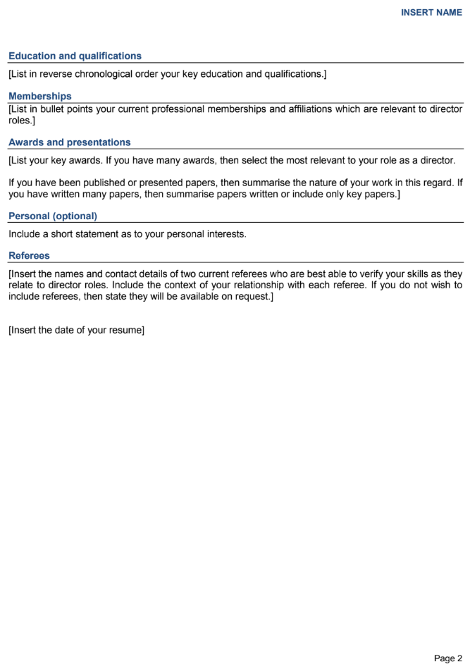
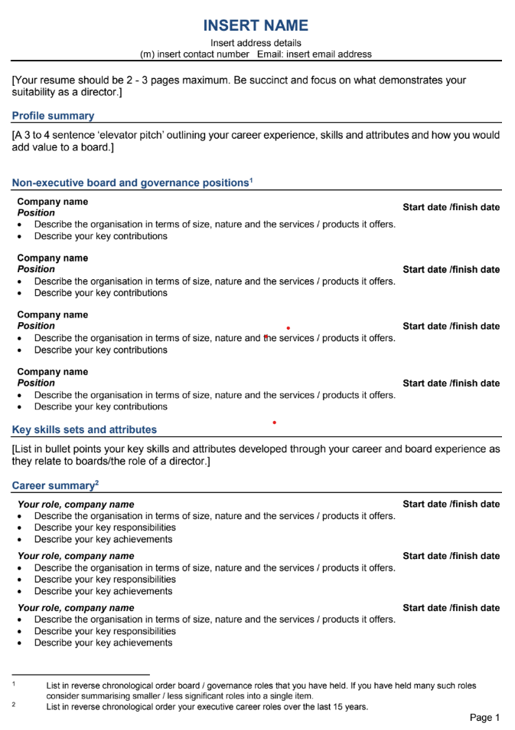

Handout (link): The Muse’s 185 powerful verbs that will make your resumé awesome article says:

‘Most resume bullet points start with the same tired old words hiring managers have read over and over (think: tasked with, responsible for, experience in) to the point where they’ve lost a lot of their meaning.’

So, choose your words carefully. Draft and redraft. Think C-A-R. Tell your story.

Draft your two-page board resumé
Homework: Use all this to draft your two-page board resumé. Don’t forget to draw on your purpose statement and pitch.

Module 7: Where to look

Board roles won’t all be advertised in the one place. You’ll need to fish around.

Handout (link): Take on Board blog Where to start the search for board roles
Handout (link): Ideas to Action blog My personal guide to LinkedIn etiquette

where would you look for a board role?

What boards are looking for

Handout (printout): A list of available board roles

prompt: | YOUR ANSWER
What do you notice about the range of organisations?

What skills are listed?

Do you notice anything else?

Pick a board

You’ll be doing a practice board interview in module 8. To prep for the interview, either:
- Choose a real board role: You don’t have to actually apply for the board role you pick, although it’s a good idea to pick one you would be interested in.
- Invent a board role: Just remember to develop a position description so your interviewer knows the organisation and the skills sought.
Some things to think about when assessing which board roles to apply for:
- The board, role, term, remuneration, etc
- Are the values and skills aligned?
- Who is already on the board?
- Any contacts in the organisation or on the board?
- What are the next steps to apply?
Homework: Find a board position description and get your board resumé ready for module 8.

Module 8: Interview
In this session you’ll be doing a practice interview.

In groups of three, you’ll each get the opportunity to be the:
- Interviewee
- Interviewer
- Observer
The rules:
- 20-minute rounds (15-minute interviews + 5-minute debrief)
- Each interviewee must provide: position description and their board resumé
- Observer to give the 5-minute and 2-minute wind-up signal
Don’t skip the debrief!

The roster

Round 1

intervieweE | intervieweR | observer

Round 2

intervieweE | intervieweR | observer

Round 3

intervieweE | intervieweR | observer

Before the rounds

Interviewees
By 5pm on __ / __ / ____you must have ‘applied’ for the role.

To apply, you need to send to your interviewer the position description for the role you are applying for, your board resume and your cover letter if you choose to do one. Don’t forget to cc to the observer and me. All your KickStarter cohort’s email addresses are in the introductory booklet.

Late applications will not be accepted. It is not fair on your interviewer.

There’s a vast amount of information available that can help you prepare for an interview. Try these:

Handout (link): Take on Board podcast: Episode 16 – prepping for a board interview
Handout (link): Get on Board Australia: How to prepare for a board interview
Handout (link): Board Direction: How to reply to board interview questions
Handout (link): Get on a Board Australia: Questions to ask at a board interview

Interviewers
Your role is to read the provided position description and ask questions. You don’t need to research or know anything about the organisation.

Asking questions:

- Choose 3-4 questions for the interview. Yes, there’s a long list below to choose from, but do not be tempted to ask more than 3-4 as the interview will go over the allocated 15 minutes.

- Please include ‘tell us a bit about yourself’ as your opening question and at least one or two ‘behavioural’ questions (e.g. ‘can you tell us about a time when you [insert skill required in the PD]?’)

- Leave time for ‘do you have any questions for us?’. You obviously won’t be able to answer those questions, however you want to hear them.

Potential interviewer questions

Introduction:
- Can you tell us a bit about yourself?
- Why does this particular board role appeal to you?
Governance style:
- How hands on do you think a non-executive director should be?
- In your view, what is the leadership role of a non-executive director?
- What do you think are the important soft skills of a non-executive director?
- What role does diversity play in a strong board?
Skills and expertise:
- What is your experience in this field of business?
- Can you tell us about a time when you... (insert one of the key selection criteria)* (Note: ask this question at least two or three times for different skills required.)
Our organisation:
- What do you perceive are our current strategic considerations?
- What do you expect will be the challenges facing our sector in the next 10-15 years?
- Where do you think your strengths and weaknesses fit in with the current board?
- What are your thoughts about our current budget and financial statements?
- How does the current term of the position fit in with your other responsibilities?
- Have you had to deal with any legal issues in past positions that would benefit our board?
- Have you considered which of our committees are a fit for you?
- How do you think the board’s expectations match with your expectations for yourself?
Connections and networking:
- How might your personal or professional connections be a useful resource to our organisation?
- Can you tell us about a time when you have drawn on your personal or professional connections?
Passion and commitment:
- What makes our organisation’s mission powerful for you?
- What interests you most about our organisation?
- Do you have personal aspirations about serving on our board?
- What does success look like to you?
- What motivates you?
- How do you see yourself fitting in socially with other board members?
Do you have any questions for us?

During the rounds

Observers

As an observer, your role is crucial in helping the others understand what they did/said,
and how they might improve their interviews as a result of the practice interview. These guidelines will help you understand the role of the observer and how to give constructive feedback at the end of the interview.

Capture what you observe – the exact words used or the behaviour observed.

Here are some examples of constructive observations:
Excellent introduction in response to ‘tell us a bit about yourself’ – clear, confident and outlined strengths well. Linked your pitch to the organisation.
During the interview, you looked down at notes too much – not enough eye contact. Looked at the other person’s tie when asking questions.
Used the challenge/action/result framework well when answering questions, although perhaps a little more ‘results’ would be useful.
Asked great questions at the end – I particularly liked when you asked about <topic>.
The feedback process

1. Ask the interviewee:
- How do you think it went?
- What went well?
- What might you do differently next time?
2. Ask the Interviewer:
- What did the interviewee do well?
- What could have been improved?
- Did the interviewee answer all your questions? Did they answer them well?
3. Give your view as the observer with positive feedback first:
- The things that went well
- The things that could have gone better
- Summarise your feedback – be as specific as possible in your suggestions

The debrief

prompt | your answer
As the interviewee, what stood out for you?

As the interviewer, what stood out for you?

As an observer, what stood out for you?

Module 9: Eyes wide open
Before we look at what it means to go into a first board role with your ‘eyes wide open’, let’s pause to reflect on and review all the modules we’ve covered in the program so far.

Program review

By now you’ve picked the module you’d like to briefly summarise for us all. We’ll end the program review with a Q&A session.

MODULE | NOTES
Module 1: Skills

Module 2: Alignment

Module 3: Commitment

Module 4: Diversity, equity, inclusion

Module 5: Pitch

Module 6: Board resume

Module 7: Where to look

Module 8: Interview

Going into your first board role with your eyes wide open
Handout (book): By now you would have received your copy of Eyes Wide Open: A First-Timer's Guide to the Real World of Boards and Company Directorship by Robyn Weatherley:

‘Eyes Wide Open is an enduring and insightful guide for all new and aspiring directors, regardless of whether the appointment is with a not-for-profit, an equal representation board, government enterprise, family-run business, tech start-up, or an ASX-listed company.’

This book will help guide you as you step into your first board role.

questions + NOTES

Your next steps…
Before we wrap up, write down what your next steps will be.

Pick five goals. Five is achievable. It could be to reach out to a board for a coffee or even to apply for a board role.

We’ll revisit these goals in the two follow-up progress sessions.

GOAL | WHAT NEEDS TO BE DONE
Goal 1:

Goal 2:

Goal 3:

Goal 4:

Goal 5:

Module 10: Progress sessions

The check-ins! Let’s celebrate the wins and workshop the challenges.

GOAL | progress SESSION 1 | PROGRESS SESSION 2
Goal 1:

Goal 2:

Goal 3:

Goal 4:

Goal 5:

Handouts

Module 1: Skills

Great Boards journal: Distinguishing Governance from Management

The Canadian Angel Investment Foundation skills chart

The AICD: Board Recruitment

VIA Signature Strengths Questionnaire

Module 3: Commitment

The AICD: general duties of directors

Thoughtpost Governance: 4-in-1 Directorship Model

Module 4: Diversity, equity, inclusion

The AICD: Which Two Heads are Better than One?

Kellogg School of Management: Better Decisions Through Diversity

Harvard Business Review: How Diversity Can Drive Innovation

Module 6: Board resumé

Take on Board podcast: Episode 6 – developing a governance CV

The Muse: 185 powerful verbs that will make your resumé awesome

Module 7: Where to look

Take on Board blog: Where to start the search for board roles

Ideas to Action blog: My personal guide to LinkedIn etiquette

Module 8: Interview

Take on Board podcast: Episode 16 – prepping for a board interview

Get on Board Australia’s How to prepare for a board interview

Board Direction: How to reply to board interview questions

Get on a Board Australia: Questions to ask at a board interview

Module 9: Eyes wide open

Eyes Wide Open: A First-Timer's Guide to the Real World of Boards and Company Directorship

